Name: ________________________________________________ Date: _______________________

# Characteristics of Linear Graphs

**Interval Notation:**

Represents an interval as a ___________________________. The numbers are the endpoints of the interval. _________________ and/or _______________ are used to show excluded or included.

**Interval** :

**Domain and Range:**

**Domain:** The _____________ that are contained in the graph. Write it from __________________.

**Range:** The ___________ that are contained in the graph. Write it from ______________________.

Examples:

1. D: _________ 2) D: _________ 3) D: _________

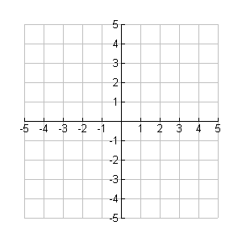R: _________ R: __________ R: _________

**Interval of Increasing and Decreasing:**

Always read from _________ to ____________

* If your finger is going up, the graph is ______________.
* If going down, the graph is ______________.

**Example**:

Inc: ___________

Dec: __________

**Zeros/Roots/Solutions**

**Intercepts**

* **x-intercept –** the point at which the line intersects the ___________________. ( )
* **y-intercept –** the point at which the line intersects the ___________________. ( )

**End Behavior:**

* What a function keeps doing after it leaves the graph
* __________ : As x goes to the right, where does y go?
* __________ : As x goes to the left, where does y go?

 1)  2) 

**∞**

**-∞**

**∞**

**-∞**

**Rate of Change:**

* The rate of change is the average ________ of a graph over a given period
* The period is defined by __________
* The rate of change formula is: